**ATAR course examination, 2024**

Question/Answer booklet

**YEAR 12 ATAR**

PHYSICAL

EDUCATION

STUDIES

|  |  |  |  |  |  |  |  |  |
| --- | --- | --- | --- | --- | --- | --- | --- | --- |
| WA Student number: In figures |  |  |  |  |  |  |  |  |

In words ___________________________________

_________________________________

**Time allowed for this paper**

Reading time before commencing work: ten minutes

Working time: two and a half hours

**Materials required/recommended for this paper**

***To be provided by the supervisor***

This Question/Answer booklet

***To be provided by the candidate***

Standard items: pens (blue/black preferred), pencils (including coloured), sharpener, correction fluid/tape, eraser, ruler, highlighters

Special Items: Nil

**Important note to candidates**

No other items may be taken into the examination room. It is **your** responsibility to ensure that you do not have any unauthorised material. If you have any unauthorised material with you, hand it to the supervisor **before** reading any further.

**Structure of this paper**

|  |  |  |  |  |  |
| --- | --- | --- | --- | --- | --- |
| Section | Number of  questions  available | Number of  questions to  be answered | Suggested  working time  (minutes) | Marks  available | Percentage  of written  examination |
| Section One Multiple-choice | 20 | 20 | 30 | 20 | 20 |
| Section Two  Short answer | 8 | 8 | 90 | 80 | 50 |
| Section Three Extended answer | 4 | 2 | 60 | 30 | 30 |
|  |  |  | **Total** | 130 | 100 |

**Instructions to candidates**

1. Write your answers in this Question/Answer booklet preferably using a blue/black pen. Do not use erasable or gel pens.
2. Answer the questions according to the following instructions.

Section One: Answer all questions in the Question/Answer booklet. For each question, circle the letter to indicate your answer. Use only a blue or black pen. If you make a mistake, place a cross through that letter, then circle your new answer. Do not erase or use correction fluid/tape. Marks will not be deducted for incorrect answers. No marks will be given if more than one answer is completed for any question.

Section Two: Write your answers in this Question/Answer booklet. Wherever possible, confine your answers to the line spaces provided.

Section Three: Consists of four (4) questions. You must answer two (2) questions. Write your answers in this Question/Answer booklet.

1. You must be careful to confine your answers to the specific questions asked and to follow any instructions that are specific to a particular question.
2. Supplementary pages for the use of planning/continuing your answer to a question have been provided at the end of this Question/Answer booklet. If you use these pages to continue an answer, indicate at the original answer where the answer is continued, i.e. give the page number.

**Section One: Multiple-choice 20% (20 Marks)**

This section has **20** questions. Answer **all** questions on the Question/Answer booklet. For each question, circle the letter to indicate your answer. Use only a blue or black pen. If you make a mistake, place a cross through that letter, then circle your new answer. Do not erase or use correction fluid/tape. Marks will not be deducted for incorrect answers. No marks will be given if more than one answer is completed for any question.

**Suggested working time: 30 minutes.**

**___________________________________________________________________**

1. Which of the following shows the greatest change in length when a muscle contracts?
   1. H zone
   2. A band
   3. Z line
   4. I band
2. Which one of the following does the human body contain the most number of?
3. muscle fibres
4. myofibrils
5. muscle fascicles
6. motor units
7. If a high frequency of impulse is sent to a muscle, which of the following is most likely to occur?
8. the muscle will contract and relax repeatedly
9. all muscle fibres in the muscle will contract at 100% intensity
10. reaction time will be improved
11. only type IIb muscle fibres will be preferentially recruited
12. A sign of overtraining for an elite sprinter would be
13. a decrease in personal best times.
14. an increase in VO2 max.
15. an increased appetite.
16. an increased resting heart rate.
17. Regina is a 10 year-old girl interested in making friends, having fun, and learning the javelin at her local little athletics team. What leadership style should her coach avoid the most with Regina’s javelin coaching?
18. Authoritarian
19. Democratic
20. Laissez-faire
21. all are suitable
22. Which of the following training activities would a little athletics coach most likely use when coaching the triple jump?
23. static-dynamic
24. complex
25. shaping
26. chaining
27. Josh is in the State U21 athletics team. His coach is very friendly and likeable, and Josh gets along with him well. His coach decides that every player returning must attend a pre-season social gathering or they will be made to fill the water bottles for the team for the rest of the season.

What leadership style is Josh’s coach displaying?

1. Authoritarian
2. Laissez-faire
3. Democratic
4. Socially cohesive
5. In 2004 the USA basketball team made history by losing to Puerto Rico in game 1 of the Olympics. This was the first time the USA had ever lost in the NBA era. Some say this was because of too much social loafing in the team. How could the coach reduce this?
6. train in large groups to gain more extrinsic motivation from the extra players
7. appoint the best player in the team as captain to provide a talented role model
8. identify key performance indicators for each player
9. set easily achievable team goals to boost morale and cohesion from multiple instances of success
10. A developing tennis player receives coaching lessons with the aim of improving their forehand. After the lessons they find they can impart much more top spin onto the ball. What is an advantage of the new technique?
11. topspin makes the tennis ball move faster through the air
12. the ball is easier to strike with the tennis racket when hitting topspin
13. they can hit higher over the net with greater ball speed
14. the ball flys further through the air with the same force before landing
15. Which of the following best demonstrates positive transfer of learning?
16. basketball to netball
17. rugby to squash
18. hockey to basketball
19. tennis to soccer
20. The Magnus effect dictates that a ball with backspin will have a lift force directed
21. diagonally forwards and up
22. forwards
23. upwards
24. diagonally forwards and down
25. Which of the following is least likely to occur to an athlete exercising in the heat for a prolonged period? A decrease in
26. blood plasma volume
27. stroke volume
28. cardiac output
29. blood viscosity
30. Which method of heat transfer is most effective in helping a runner lose heat during a race?
31. Evaporation
32. Convection
33. Conduction
34. Radiation
35. Which of the following is **not** correct when comparing air at Mt Everest and air at sea level?
36. there is more nitrogen than oxygen in both locations
37. the partial pressure of oxygen is lower at Mt Everest
38. there is a higher percentage of oxygen at sea level
39. the barometric pressure is lower at Mt Everest
40. Every year there is a longest kick competition over the Yarra River in Melbourne. Players try to kick an AFL ball the furthest to win a prize. Which of the following pieces of advice would you **not** give?
41. use as many body parts as possible
42. utilise your fastest muscles first
43. direct all forces towards the target
44. follow through towards the target
45. An elite cricketer’s off-season phase of a training program should be used to
46. take a holiday and relax mentally and physically.
47. maintain fitness by doing small amounts of light batting and bowling.
48. regularly meet with the coach to discuss strategies and tactics for the upcoming season.
49. complete enjoyable activities not related to cricket that maintain fitness levels.
50. Cliff Jumping is an adrenaline filled sport where divers often risk landing on dangerous rocks below if they cannot jump out far enough. To maximise distance jumped from a standing start, which angle of projection seems the most appropriate to clear the rocks?
51. 45 degrees
52. 30 degrees
53. 60 degrees
54. 90 degrees
55. The sport of squash requires athletes to hit a rubber ball against a wall with precision and tactical awareness to win the game. Elite squash players use balls that are made less bouncy than beginner squash balls. What else could someone do to decrease the bounciness of a ball?
56. play squash at a higher altitude
57. apply topspin to the squash ball
58. hit the squash ball with higher velocity
59. apply higher peak force to the squash ball over less time
60. Which of the following would occur immediately after arriving at altitude?
61. increased oxygen in blood
62. increased sweat rate
63. increased heart rate
64. vasoconstriction of blood vessels
65. The connective tissue surrounding a fascicle is called the:
66. epimysium
67. endomysium
68. epidermis
69. perimysium

**End of Section One**

**Section Two: Short answer 50% (80 Marks)**

This section has **eight** questions. Answer **all** questions. Write your answers in the spaces provided. Supplementary pages for planning/continuing your answers to questions are provided at the end of this Question/Answer booklet. If you use these pages to continue an answer, indicate at the original answer where the answer is continued, i.e. give the page number.

**Suggested working time: 90 minutes.**

**_________________________________________________________________________**

**Question 21**  **(13 marks)**

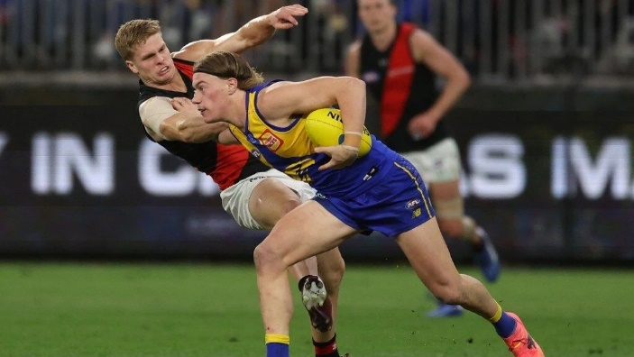Australian Football League player Harley Reid has recently been crowned the ‘fend off king’ due to his ability to push opponents off the ball while keeping his balance.

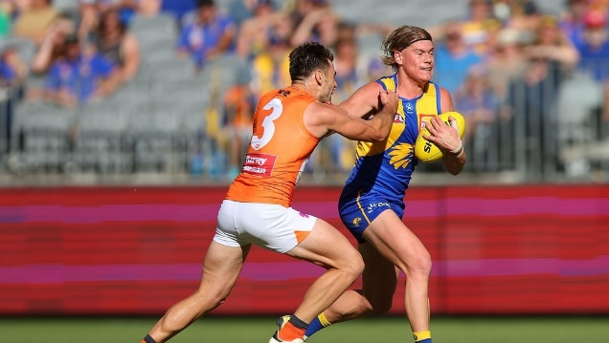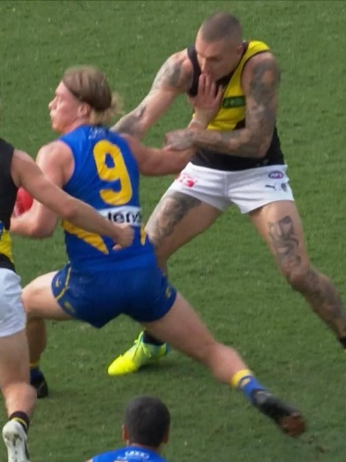

1. Outline **three** ways Harley could maintain his balance when executing a fend off. (3 marks)

__________________________________________________________________________________________________________________________________________________________________________________________________________________________________________________________________________________________________________________________________________________________________________________________________________________

1. When Harley practises his fend-offs at training, his midfield coach often holds a tackle bag. Identify the biomechanical principle behind this and explain the benefit to the coach. (3 Marks)

__________________________________________________________________________________________________________________________________________________________________________________________________________________________________________________________________________________________________________________________________________________________________________________________________________________

1. Name and describe the training activity that Harley’s coach is using in (b) with the tackle bag and identify the category of transfer of learning that is occurring. (4 marks)

________________________________________________________________________________________________________________________________________________________________________________________________________________________________________________________________________________________________________________________________________________________________________________________________

1. Some say Harley has gained more media attention than any other first year player in the history of the AFL. The television cameras appear to spend a disproportionate amount of time on him compared to the other players. Outline **three** benefits of video analysis that Harley could utilise to improve. (3 marks)

____________________________________________________________________________________________________________________________________________________________________________________________________________________________________________________________________________

**Question 22**  **(12 marks)**

2024 World’s Strongest Man winner Tom Stoltman has won 3 out of the last 4 competitions. After losing in 2023 he began using hyperbaric chambers for recovery every week and increased his workload in the gym.

1. Other than a hyperbaric chamber, name **two** other physiological recovery strategies Stoltman could use during his training program and outline how they can benefit him. (4 marks)

_______________________________________________________________________________________________________________________________________________________________________________________________________________________________________________________________________________________________________________________________________________

Stoltman’s favourite event is the Atlas stones. This event involves competitors lifting a heavy stone over a 122 cm high bar. Stoltman currently holds the world record in this event, successfully lifting 273 kg giving him the nickname “The King of Stones”.

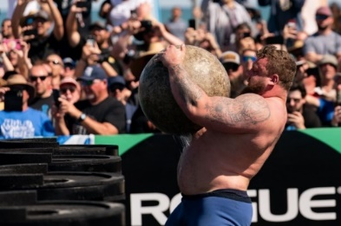

1. Draw and label a graph of the force-velocity relationship for muscle contraction and explain how Stoltman may have applied it in this lift. (4 marks)

____________________________________________________________________________________________________________________________________________________________________________________________________________________________________________________________________________

During the ‘Atlas stones’ event in the World’s Strongest Man competition. The first and lightest of five stones lifted weighs 100 kg.

1. Compare **two** differences in motor unit recruitment between Stoltman lifting the 100 kg stone compared to his record-breaking attempt of 273 kg. (4 marks)

__________________________________________________________________________________________________________________________________________________________________________________________________________________________________________________________________________________________________________________________________________________________________________________________________________________

**Question 23 (4 marks)**

Wingsuits are inventions by skydivers aiming to travel large horizontal distances in the air.

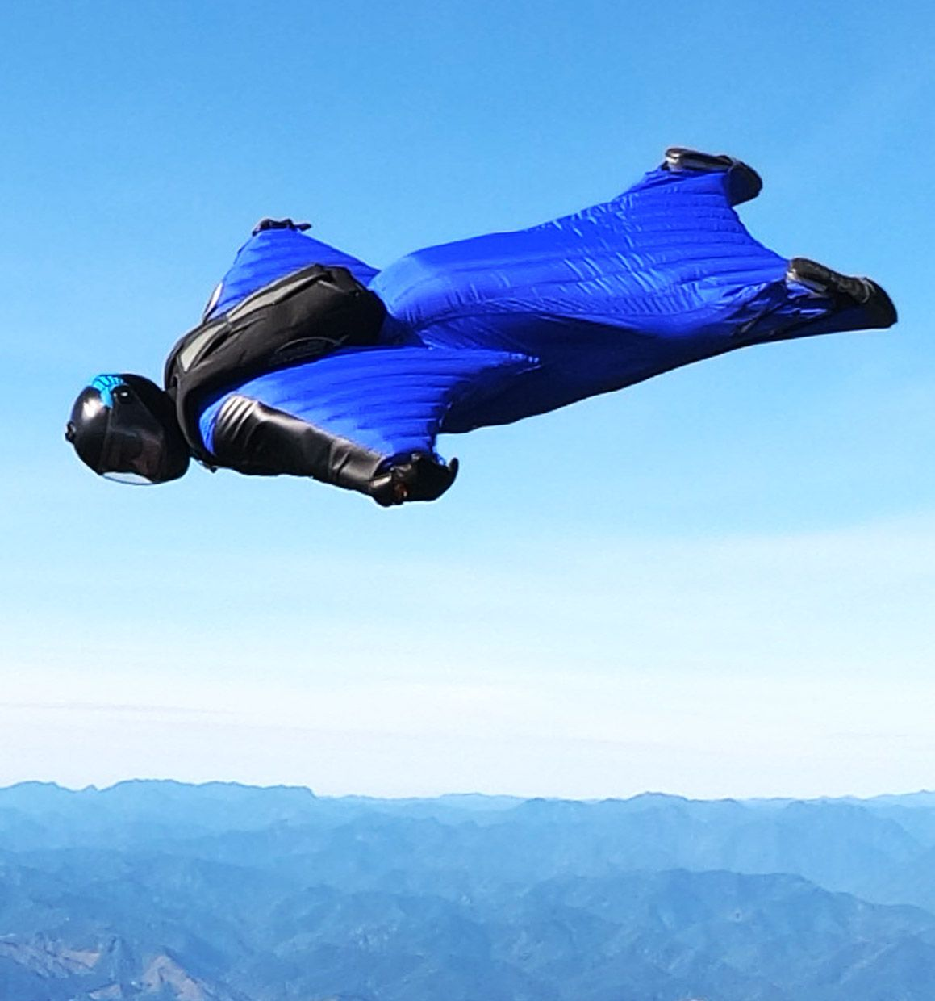

With reference to Bernoulli’s principle, complete the diagram of the airflow and biomechanics over the skydiver’s arm. (4 marks)

|  |
| --- |
|  |

**Question 24 (12 marks)**

Harry Garside (pictured left in the image below) is a star Australian boxer with multiple Australian Championships to his name.

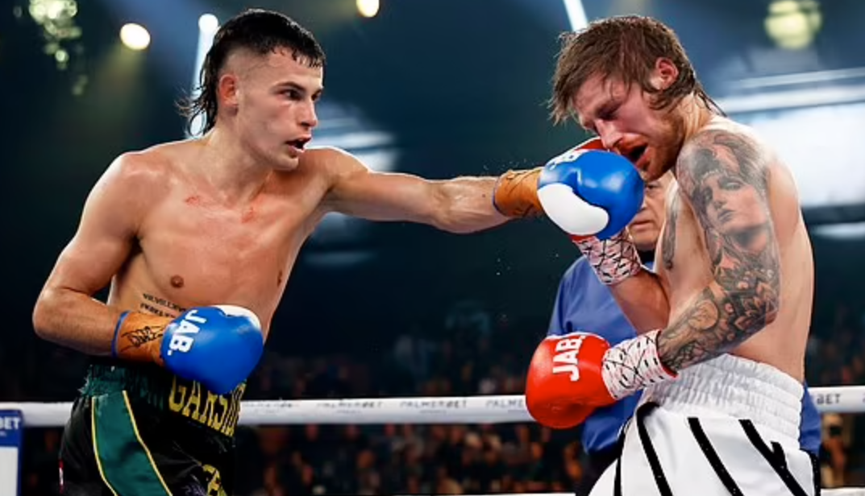

1. Discuss what a sarcomere would most likely look like in Harry’s left tricep muscle at the exact moment in the picture above where his glove is connecting with his opponent. (4 marks)

_______________________________________________________________________________________________________________________________________________________________________________________________________________________________________________________________________________________________________________________________________________

Harry has inspired many young people not only with his boxing ability and dedication, but with his confidence to express himself. He has been known to run personal development workshops for young people.

1. Name **two** mental skill strategies Harry could teach to aspiring boxers in his personal development seminars to boost their confidence before a boxing match and provide an example of how each could be applied. (4 marks)

_______________________________________________________________________________________________________________________________________________________________________________________________________________________________________________________________________________________________________________________________________________

1. Harry is also known for his unusual training habits, completing ballet and army training which he says is critical to his success. Describe **two** ways in which these activities could improve Harry’s boxing ability. (4 marks)

____________________________________________________________________________________________________________________________________________________________________________________________________________________________________________________________________________

______________________________________________________________________________________________________________________________________

**Question 25**  **(15 marks)**

Bluff Knoll is the highest peak in the Stirling Ranges at 1,099 m above sea level. Climbers are required to ascend approximately 650 m to get to this point. It has become one of the most popular climbs amongst tourists.

1. Identify and describe **two** methods of altitude training in relation to living and training circumstances for an athlete wanting to climb to Bluff Knoll’s summit in a record time. (6 marks)

_________________________________________________________________________________________________________________________________________________________________________________________________________

_______________________________________________________________________________________________________________________________________________________________________________________________________________________________________________________________________________________________________________________________________________

1. Identify **three** adaptations to altitude training that an athlete may experience after completing altitude training and outline their benefit to performance. (6 marks)

______________________________________________________________________________________________________________________________________

_________________________________________________________________________________________________________________________________________________________________________________________________________

_________________________________________________________________________________________________________________________________________________________________________________________________________

(c) Temperatures at the top of Bluff Knoll can often be below freezing with regular accounts of snow at the peak. Outline **three** immediate effects of the cold a climber might experience at the summit of Bluff Knoll. (3 marks)

___________________________________________________________________

_________________________________________________________________________________________________________________________________________________________________________________________________________

**Question 26** **(14 marks)**

Montreal 1976 was the first Olympics in which Australia didn’t win a gold medal. This caused public outcry and shock and was the driving force behind the establishment of the Australian Institute of Sport (AIS). While this provided vast resources to highly task motivated athletes, it also created opportunities to forge more social cohesion among athletes.

1. Justify which leadership style would most likely suit experienced and highly motivated athletes when choosing coaches for the newly formed AIS. (3 marks)

_________________________________________________________________________________________________________________________________________________________________________________________________________

___________________________________________________________________

1. For the coaching style above outline **two** characteristics of athletes for whom it would not be suitable. (2 marks)

____________________________________________________________________________________________________________________________________________________________________________________________________________________________________________________________________________

1. Identify **one** method in which coaches in the newly formed AIS could promote social cohesion amongst their athletes and explain why this would be important in a situation as that in the AIS. (4 marks)

__________________________________________________________________________________________________________________________________________________________________________________________________________________________________________________________________________________________________________________________________________________________________________________________________________________

1. With reference to a 3rd class lever, outline the mechanics of this type of lever, and explain how javelin throwers (with a greater average height) use these levers compared to weightlifters (with a shorter average height). (5 marks)

_______________________________________________________________________________________________________________________________________________________________________________________________________________________________________________________________________________________________________________________________________________

_________________________________________________________________________________________________________________________________________________________________________________________________________

**Question 27**  **(4 marks)**

Golf club selection can vary depending on whether it is summer or winter. Below is a graph showing the average driving distances in golf in different temperatures (using the same club). The driving distance is from impact to where the ball first lands.

|  |  |
| --- | --- |
| **Temperature (Celsius)** | **Driving distance (meters)** |
| 2° | 221 |
| 7° | 223 |
| 13° | 225 |
| 18° | 227 |
| 24° | 229 |
| 29° | 230 |
| 35° | 232 |

Explain **two** reasons why golf balls are hit further in higher temperatures. (4 marks)

__________________________________________________________________________________________________________________________________________________________________________________________________________________________________________________________________________________________________________________________________________________________________________________________________________________

**Question 28 (6 marks)**

AFL coach Chris Scott currently has a winning percentage of above 70% with the Geelong Cats. This is one of the highest of all time. He also has one of the oldest lists in the league, making proper preparation during the year extremely important.

Identify an objective and outline **two** characteristics of the pre-season and in-season for the Geelong Cats that Chris may have planned for. (6 marks)

Pre-season

______________________________________________________________________________________________________________________________________

______________________________________________________________________________________________________________________________________

___________________________________________________________________

In-Season

______________________________________________________________________________________________________________________________________

______________________________________________________________________________________________________________________________________

___________________________________________________________________

**Section Three: Extended answer 30% (30 Marks)**

This section contains **four** questions. You must answer **two** questions. Write your answers in the spaces provided. Supplementary pages for planning/continuing your answers to questions are provided at the end of this Question/Answer booklet. If you use these pages to continue an answer, indicate at the original answer where the answer is continued, i.e. give the page number.

**Suggested working time: 60 minutes.**

**___________________________________________________________________**

**Question 29 (15 marks)**

For the first time ‘Breaking’ will be an event at the 2024 Paris Olympics. It is a style of dance which emerged from the hip-hop culture in the 1970s and is characterised by explosive acrobatic movements and stylised footwork to the beat music tracks. Jeff Dunne (pictured below) and Rachel Gunn will be representing Australia in the 2024 Olympics.

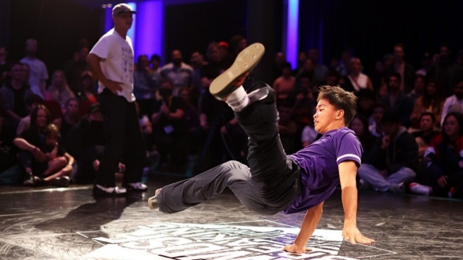

Athletes take turns performing moves in what is known as the ‘throw down’. Each throw down lasts for 60 seconds and an athlete can perform up to five of these in a competition.

1. Identify which muscle fibre type Jeff and Rachel are most likely to possess and compare **four** characteristics of this muscle fibre that enhance their performance compared to another muscle fibre. (9 marks)

_______________________________________________________________________________________________________________________________________________________________________________________________________________________________________________________________________________________________________________________________________________________________________________________________________________________________________________________________________________________________________________________________________________________________________________________________________________________________________________________________________________________________________________________________________________________________________________________________________________________________________________________________________________________________________________________________________________________________________________________________________________________________________________________________________________________________________________________________________________________________________________________________________________________________________________________________________________________________________________________________________________________________________________________________________________________________________________________________________________________________________________________________________________________________________________________________________________________________________________________________________________________________________________________________________________________________________________________________________________________________________________________________________________________________________________________________________________________________________________________________________________________

_________________________________________________________________________________________________________________________________________________________________________________________________________

Often a highlight of the breaking routine is when athletes complete power moves, which are complex movements often involving spinning their whole-body upside down on their head or hands.

1. Describe how a performer could apply each of **three** biomechanical concepts to control how fast they were spinning. (6 marks)

____________________________________________________________________________________________________________________________________________________________________________________________________________________________________________________________________________________________________________________________________________________________________________________________________________________________________________________________________________________________________________________________________________________________________________________________________________________________________________________________________________________________________________________________________________________________________________________________________________________________________________________________________________________________________________________________________________________________________________________________________________________________________________________________________________________________________________________________________________________________________________________________________________________________________________________________________________________________________________________________________________________________________________________________

**Question 30 (15 marks)**

In 2023, Australia’s national women’s soccer team ‘The Matildas’, defeated France in the quarter-final in a nail-biting penalty shootout to make history and become the first Australian team to make the semi-finals in world cup soccer.

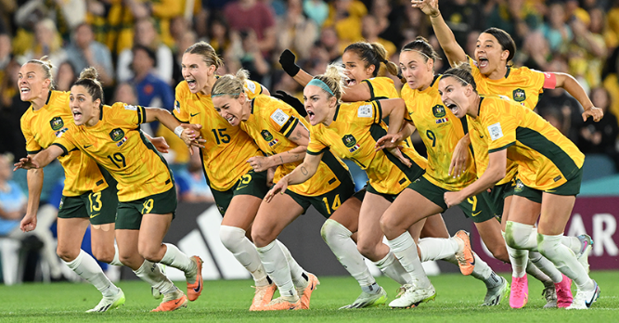

Define ‘arousal’ and describe how the goalkeeper Mackenzie Arnold might be feeling. Identify **four** strategies that may be used to manage her arousal level and explain how these would benefit her in preparation for the penalties. (15 marks)

__________________________________________________________________________________________________________________________________________________________________________________________________________________________________________________________________________________________________________________________________________________________________________________________________________________________________________________________________________________________________________________________________________________________________________________________________________________________________________________________________________________________________________________________________________________________________________________________________________________________________________________________________________________________________________________________________________________________________________________________________________________________________________________________________________________________________________________________________________________________________________________________________________________________________________________________________________________________________________________________________________________________________________________________________________________________________________________________________________________________________________________________________________________________________________________________________________________________________________________________________________________________________________________________________________________________________________________________________________________________________________________________________________________________________________________________________________________________________________________________________________________________________________________________________________________________

___________________________________________________________________________________________________________________________________________________________________________________________________________________________________________________________________________________________________________________________________________________________________________________________________________________________________________________________________________________________________________________________________________________________________________________________________________________________

**Question 31 (15 marks)**

For many years, athletes across a variety of sports have relied on enhancers, both legal and illegal, to improve their performance and give them a competitive edge.

Identify **one** physiological side effect for each of the performance enhancers listed below and explain how each could potentially benefit a swimmer.

* caffeine
* protein powder
* erythropoietin (EPO)
* creatine
* anabolic steroids

______________________________________________________________________________________________________________________________________________________________________________________________________________________________________________________________________________________________________________________________________________________________________________________________________________________________________________________________________________________________________________________________________________________________________________________________________________________________________________________________________________________________________________________________________________________________________________________________________________________________________________________________________________________________________________________________________________________________________________________________________________________________________________________________________________________________________________________________________________________________________________________________________________________________________________________________________________________________________________________________________________________________________________________________________________________________________________________________________________________________________________________________________________________________________________________________________________________________________________________________________________________________________________________________________________________________________________________________________________________________________________________________________________________________________________________________________________________________________________________________________________________________________________________________________________________________________________________________________________________________________________________________________________________________________________________________________________________________________________________________________________________________________________________________________________________________________________________________________________________________________________________________________________________________________________________________________________________________________________________________________________________________________________________________________________________________________________________________________________________________________________________________________________________________________________________________

**Question 32 (15 marks)**

In 2023 Kate Baker won the Rottnest Marathon with an impressive time of 2:47:53. This was the first time in the history of the event that a female had won overall. To run a marathon, you must have a strong nutritional plan to ensure that you don’t run out of energy during the race.

1. Discuss how Kate may prepare nutritionally for each phase: 1-day before; during; and immediately after the race so that she can perform at her peak, by including **three** nutritional strategies for each phase. (9 marks)

______________________________________________________________________________________________________________________________________________________________________________________________________________________________________________________________________________________________________________________________________________________________________________________________________________________________________________________________________________________________________________________________________________________________________________________________________________________________________________________________________________________________________________________________________________________________________________________________________________________________________________________________________________________________________________________________________________________________________________________________________________________________________________________________________________________________________________________________________________________________________________________________________________________________________________________________________________________________________________________________________________________________________________________________________________________________________________________________________________________________________________________________________________________________________________________________________________________________________________________________________________________________________________________________________________________________________________________________________________

_______________________________________________________________________________________________________________________________________________________________________________________________________________________________________________________________________________________________________________________________________________

1. Define what is meant by ‘tapering’ and ‘recovery strategies’ and explain how Kate can use these in the lead up to the event to be in her ideal performance state for the race. (6 marks)

_________________________________________________________________________________________________________________________________________________________________________________________________________________________________________________________________________________________________________________________________________________________________________________________________________________________________________________________________________________________________________________________________________________________________________________________________________________________________________________________________________________________________________________________________________________________________

**End of questions**

Supplementary page

Question number: ___________________

____________________________________________________________________________________________________________________________________________________________________________________________________________________________________________________________________________

____________________________________________________________________________________________________________________________________________________________________________________________________________________________________________________________________________

____________________________________________________________________________________________________________________________________________________________________________________________________________________________________________________________________________

____________________________________________________________________________________________________________________________________________________________________________________________________________________________________________________________________________

____________________________________________________________________________________________________________________________________________________________________________________________________________________________________________________________________________

___________________________________________________________________

Supplementary page

Question number: ___________________

______________________________________________________________________________________________________________________________________

____________________________________________________________________________________________________________________________________________________________________________________________________________________________________________________________________________

____________________________________________________________________________________________________________________________________________________________________________________________________________________________________________________________________________

_______________________________________________________________________________________________________________________________________________________________________________________________________________________________________________________________________________________________________________________________________________

____________________________________________________________________________________________________________________________________________________________________________________________________________________________________________________________________________

_________________________________________________________________________________________________________________________________________________________________________________________________________

**ACKNOWLEDGEMENTS**

**Question 21a**

https://www.themercury.com.au/sport/afl/cheat-code-harley-reid-blows-afl-away-as-eagles-demolish-tigers/news-story/4d15845088e7fb84abb49bd32d045631

https://www.afl.com.au/video/1122891/harleys-double-dont-argue-sends-home-crowd-wild?videoId=1122891&modal=true&type=video&publishFrom=1714825149001

https://www.afl.com.au/news/1095325/almost-untackleable-west-coast-eagle-harley-reids-fend-offs-leave-teammates-in-awe

**Question 22b**

https://www.the-sun.com/sport/7936683/worlds-strongest-man-2023-live-bodybuilding/

**Question 23**

<https://squirrel.ws/wingsuits/sprint/>

https://www.quora.com/What-is-the-physics-of-an-airplane-flight

**Question 24**

https://www.dailymail.co.uk/sport/boxing/article-11388603/Dress-wearing-Aussie-boxer-Harry-Garside-pinpoints-day-changed-outlook-life.html

**Question 29**

https://www.olympics.com.au/olympians/jeff-dunne/

**Question 30**

https://www.matildas.com.au/news/matildas-make-history-defeating-france-dramatic-penalty-shoot-out